ONE-OF-A-KIND GOLD CHALLENGE
YOUR TASK: Tap into your holiness – what is unique or special about you – and be God’s partner in the world.

For the GOLD challenge, you have to FIRST figure out what you are good at doing by asking friends and family.

THEN, you’re going to create an I-am-Special “word cloud” with this information. Very cool! BUT know in advance it will take a lot of patience to put together on a computer.

STEP ONE: Learn what makes you special (holy!)
The קְדוּשַׁת הַשֵׁם blessing says that God is holy and that God’s name is holy, in other words that God is unique and special. If God is holy, special, unique, with one-of-a-kind talents, then we also have very special, unique talents!

Talk to 10 friends or family members. Ask EACH person to think about YOU and offer 5 different ideas that finish the sentence:
(YOU) is good at __________.
For example, someone might answer that YOU are very good at:
- Cooking
- Reading
- Hugging
- Being a good friend
- Knowing when I’m sad
Getting 5 answers from each person will give you 50 ideas about YOU. To remember what family and friends say about you, write each answer they give you in one of the 50 squares on the next page. It’s okay if several people give the same answer. Each time someone says it, write the answer down again!

(YOU) is good at _____

STEP TWO:
Read through the list of 50 things your family and friends say you are GOOD at doing.
Now put a CIRCLE around all the things that you really, really like doing.
You might be good at lots of things, but you probably have some things you really, really LIKE to do.

STEP THREE:  Write down three things that you want to change in the world. Think big and think with your heart. Some children your age are bothered by:  - children going to be hungry every night OR  - children bullying other children OR  - trees being cut down so that new homes can be built OR  - something else! | Write your three answers, below.  Wants _____________________________________  ___________________________________________  Wants _____________________________________  ___________________________________________  Wants _____________________________________  ___________________________________________  For example you might write,  Wants to help children who are hungry

STEP FOUR: Make an “I am special” word cloud!  What’s a word cloud? It’s a very cool “cloud” made of words! [Duh!]  First you need to make a document with all the words you are going to use. So open up a writing document (for example, Microsoft Word) and type the following on one piece of “paper.” If the instructions, below, are confusing to you, feel free to ask an adult or friend to help you.  - Type your FIRST name 20 times.  - Type each of the 50 things people said you are good at doing. But here are some special instructions that will make your word cloud very, very cool:  - As much as possible use one word.  Joey’s grandmom said he was “great at hugging”.  Joey typed just one word, “hugger”  - If more than one person said the same thing, type that word more than once.  Joey’s mom AND dad both said “cooking.”  Joey typed the word “cooking” twice  - If more than one person said the same thing but used different words, try and type the idea using the same word.  Joey’s best friend said he was good at listening.  Joey’s aunt said she liked how he listened.  Joey typed “listener”  - If an idea is more than one word long, put a “tilde” between the words  A tilde is this ~ and is found on the TOP of the key to the left of the numeral 1.  To type it you have to hit SHIFT and then the tilde key  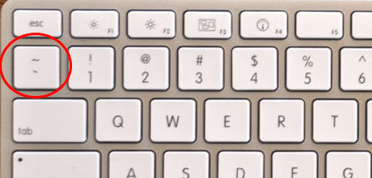  Joey’s uncle said he was “very caring with animals”  Joey typed very~caring~with~animals”  - Anything you circled (because you LIKE doing it), type 3 more times.  One of the things Joey circled was “very caring with animals” so he typed it 3 more times.  - Finally, type each of the answers you gave in Step Three (above), 3 times WITH the tilde ~ in between words.  Joey had filled in the blanks with these words:  Wants to stop bullying  Wants to stop the abuse of animals  Wants to help children with ADHD  - When you have all your words and phrases typed up, go online and click on:  http://www.wordle.net/create  COPY all the words in your document and PASTE them in the box  on the Wordle page. Then click “GO”  Joey pasted in this list:  Joey Joey Joey Joey Joey Joey Joey Joey Joey Joey  Joey Joey Joey Joey Joey Joey Joey Joey Joey Joey  hugger  cooking cooking listener listener  singer singer singer soccer soccer soccer soccer soccer  being~a~friend being~a~friend  computer~games computer~games computer~games computer~games  math math math math hiking hiking hiking hiking Hebrew Hebrew soccer soccer  very~caring~with~animals  very~caring~with~animals very~caring~with~animals very~caring~with~animals  Wants~to~stop~bullying  Wants~to~stop~bullying  Wants~to~stop~bullying  Wants~to~stop~the~abuse~of~animals Wants~to~stop~the~abuse~of~animals Wants~to~stop~the~abuse~of~animals  Wants~to~help~children~ with~ADHD Wants~to~help~children~ with~ADHD  Wants~to~help~children~ with~ADHD | THIS IS WHAT “JOEY” TYPED,  USING OUR INSTRUCTIONS:  Joey Joey Joey Joey Joey  Joey Joey Joey Joey Joey  Joey Joey Joey Joey Joey  Joey Joey Joey Joey Joey  hugger  cooking cooking  listener listener  very~caring~with~animals  very~caring~with~animals very~caring~with~animals very~caring~with~animals  Wants~to~stop~bullying  Wants~to~stop~bullying  Wants~to~stop~bullying  Wants~to~stop~the~abuse~of~animals Wants~to~stop~the~abuse~of~animals Wants~to~stop~the~abuse~of~animals  Wants~to~help~children~ with~ADHD Wants~to~help~children~ with~ADHD  Wants~to~help~children~ with~ADHD  If the Wordle website says you need to update JAVA to make this work, then an adult needs to click on the JAVA update link. It may take a few minutes to install.  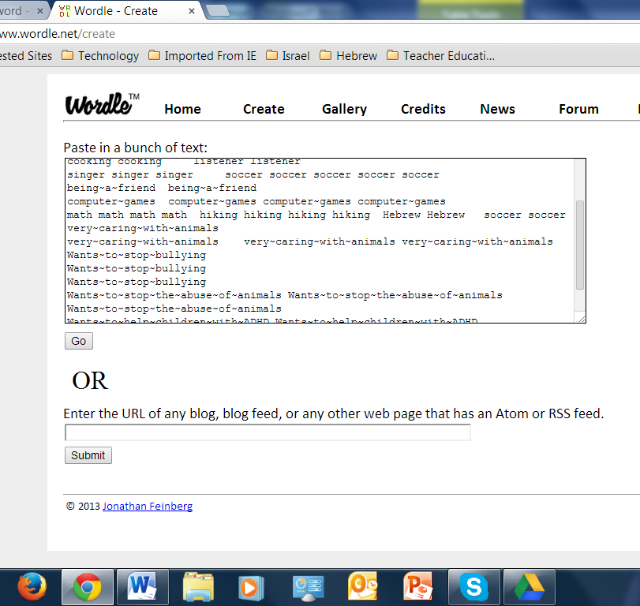  JAVA needs to “RUN” each time you create a Wordle.
This was Joey’s first Wordle but he noticed that his phrase about children with ADHD wasn’t together.

That meant that when he first typed it, he didn’t put the tilde in the right place in the phrase, “wants to help children with ADHD”
Joey made a mistake and first typed:
Wants~to~help~children with~ADHD

OOPS!
No tilde!

So Joey went back to Wordle.net/create. He fixed the tilde in the phrase and clicked GO again.

This time he got

But he didn’t like the font that came up.
So he clicked RANDOMIZE
until he got the look that he liked.
He liked this version of his Wordle a lot!

And how do these great GONNA STAND UP “I am Special, One-of-a-Kind” Wordles come to us at the website?

You have two choices, each will get it to us as a .jpg:

You may print your word cloud and then scan it into your computer as a .jpg and send it along to GonnaStandUp@jecc.org. This will turn out great looking! | You may take a photo of your screen with the word cloud and send it along. It won’t look as sharp as printing and scanning, but it still looks pretty darn good!!!!!  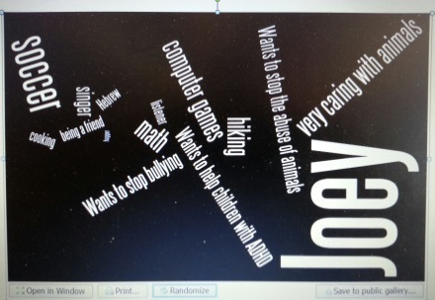

THAT’S IT!! NOW GO BACK TO THE WEBSITE AND LET US KNOW YOU ARE READY FOR YOUR BADGE!

