ANCESTORS GOLD CHALLENGE
This is a challenge you will do by yourself, though you’ll be talking to a LOT of people!
YOUR TASK: Put yourself in the chain of Jewish tradition! The אָבוֹת וְאִמָהוֹת (Avot V’Imahot) prayer (which you’ll find on this page: http://www.imgonnastandup.org/ancestors-challenge.html) tells us that each of our early Torah ancestors had their own relationship with God, their own connection to God. To earn the GOLD badge you need to:

- Interview 18 adults to discover their relationship with God
- Share what you learned in a creative way
- Put yourself in the chain of Jewish tradition - let us know who is the God of YOU!!

STEP ONE: lnterview 18 adults to discover their relationship with God.
With the help of a parent, teacher or other adult, make a list of 18 adults you think would be open to talking to you about God. These may be parents, grandparents, aunts, uncles, teachers, rabbis, friends of your family and even adults hanging around a synagogue, JCC or other interesting place! Teens, age 13 and above, are also okay to interview. You might talk to an adult or two who aren’t Jewish, but the conversation should be about “God,” and not about Jesus. ;-)
Make 3 copies of the Ancestors Gold Challenge Interview Form (on page 4 of this packet), or write the information onto a sheet of paper.
For each person you interview
  - Explain what you are doing. You could say something like, “I’m working on an online challenge and need to interview 18 adults about God. Could I ask you one question?”

  - If the adult says “yes” write down his or her name in the middle column of the Interview form.

  - Say to the adult, “I’m curious about your relationship to God, OR how you think about God. Could you tell me your ending to either of these sentences:
    - “My God is ________”
OR
    - “My God ____.”

  - On the Interview Form, write down the person’s answer.

  - Feel free to ask the adult a question or two about his or her answer. For instance:
  - You could ask: Can you tell me more about that?
  - You could say: I’m not sure I really understand. Can you give me an example?
  - You could ask: Do you pray to God? Or talk to God?

STEP TWO: Share what you learned in a creative way.  We posted some photos of what these could look like on this page of the “I’m Gonna Stand Up” website. Make sure to include the phrase “The God of (name)” for each. For instance you could:  - Draw a tree on a large sheet of paper or posterboard. Put everyone’s answer onto the tree as an “apple.” For instance, one apple might say, “The God of Aunt Anna is like a friend.”  - Make a mobile using a hanger and 9 circles or other shapes cut from file cards or construction paper. Put everyone’s answer on the items that hang down – write one answer on each side of the card.  - Video yourself doing a rap of the 18 answers. [Make sure that you are not wearing clothing that identifies your school, camp or location!] | 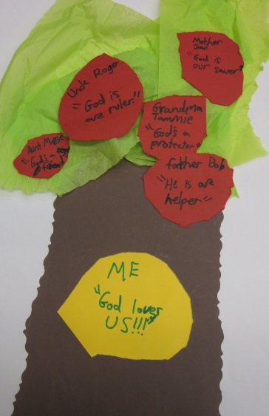
STEP THREE: Put yourself in the chain of Jewish tradition - let us know who is the God of YOU!!  Talking to 18 adults should have given you some new ideas about God.  Our ancestor, Abraham, had a very special way to connect to God. His wife, Sarah, had a different relationship to God. Your aunt, uncle, grandparent and teacher also have special connections to God.  Spend some time thinking about how you’d describe “The God of YOU!” You might need a few days or a week or two to decide how you want to describe your relationship with, or connection to God, and that’s okay.  Take a sheet of paper and with a brightly colored marker write on it:  The God of  (put your FIRST NAME)  (write your answer)  Have a parent or other adult take a photo of you with this sign held in front of you at the level of your belly. The photo should NOT include your face, but should only show the middle part of your body. Send the photo to ImGonnaStandUp@jecc.org.  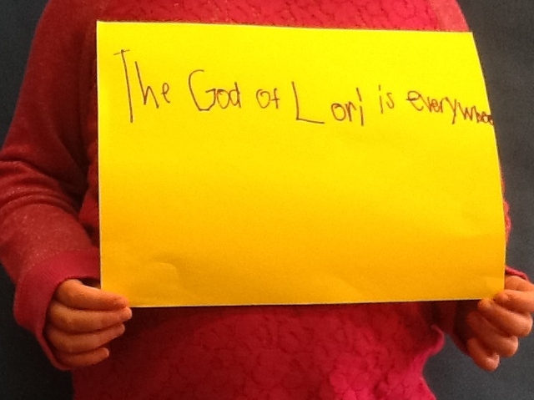  These photos will be posted in our photo gallery on our website: http://www.imgonnastandup.org/ancestors-gold-challenge_instructions.html | The God of  Megan  created the world  The God of  Mike  is not an old man with a beard in the sky  The God of  Tony  is someone I can talk to

Ancestors Gold Challenge Interview Form
אֱלֹהֵי (Elohai) the God of | Write in this space the name of the adult who you talk to | Ask the adult to finish this sentence:  “For me, God is _________” OR “For me, God _________”  Write what he or she says in the box, below
EXAMPLE:  אֱלֹהֵי (Elohai) the God of >> | Aunt Anna | is like a friend.
אֱלֹהֵי (Elohai) the God of >>

אֱלֹהֵי (Elohai) the God of >>

אֱלֹהֵי (Elohai) the God of >>

אֱלֹהֵי (Elohai) the God of >>

אֱלֹהֵי (Elohai) the God of >>

אֱלֹהֵי (Elohai) the God of >>

