SHABBAT GOLD CHALLENGE

YOUR TASK: This is our challenge to you - to light the Shabbat candles on Friday night and then to spend a full day doing the right thing. That means no mean words, no put-downs, no eye-rolling at your parents, no gossiping ... nothing that hurts someone else! You are going to become God's partner in the world - just as we praise God for making the day holy (מְקַדֵשׁ הַשַׁבָּת m'kadesh haShabbat), you are going to make the day holy by being a better person. Really!

STEP ONE: Make plans for this very special Shabbat.  - If your family doesn't usually light candles, have a Shabbat dinner or go to services, then you need to ask your parents to make sure you have two candles to light right before dinner on Friday night. You may choose to do other things that celebrate the start to Shabbat, or just light the candles.  Need help with the blessings?  Check this page from MyJewishLearning.com (http://tiny.cc/4yzecx) - make sure to scroll down to the bottom to see the video (you can sing along!).  - If your family usually enjoys the start of Shabbat together (candles, wine/grape juice, hallah, etc), then start Shabbat as you normally do. | 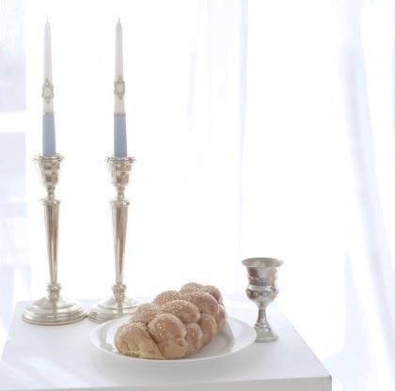

STEP TWO: Once you light the Shabbat candles you have to work very, very hard at creating a Shabbat that is holy and special. And that starts with your behavior to family, friends and even strangers. That means that for 25 hours - from the start of dinner on Friday night until three stars come out on Saturday night:
- you cannot be mean to others (in words or actions)
- you cannot talk about people behind their back
- you may not roll your eyes because you don't like what someone said
- you should not gossip or spread rumors
- you can't make people feel little or small

In other words, you have to help the day be special through your behavior. What happens if you forget?
- If YOU catch yourself about to do something you agreed not to do on Shabbat, you need to say מְקַדֵשׁ הַשַׁבָּת (m'kadesh haShabbat)
- If a parent, family member or friend catch you doing something you agreed not to do on Shabbat, they need to say to you: הַשַׁבָּת מְקַדֵשׁ (m'kadesh haShabbat). Consider it a reminder!
Give copies of the next page to your family and friends so they can help you complete this challenge!

INSTRUCTIONS FOR FAMILY AND FRIENDS:

I’m working on a very special challenge for Shabbat. For 25 hours - from the start of dinner on Friday night until three stars come out on Saturday night, I am working hard to make Shabbat a very special time, a holy time. That means I am not going to:
- be mean to others (in words or actions)
- talk about people behind their back
- roll my eyes because I don't like what someone said
- gossip or spread rumors
- make people feel little or small

If I forget, you can help me still earn the challenge by saying to me the following two words in Hebrew.

מְקַדֵשׁ הַשַׁבָּת
(m'kadesh haShabbat)

The phrase means: making Shabbat holy or special. The Torah says that God made Shabbat holy (special!) … and that’s my goal, too!

