For a translation of the Avot blessing in your prayerbook, turn to:  Page 106 in your Sim Shalom prayerbook. | 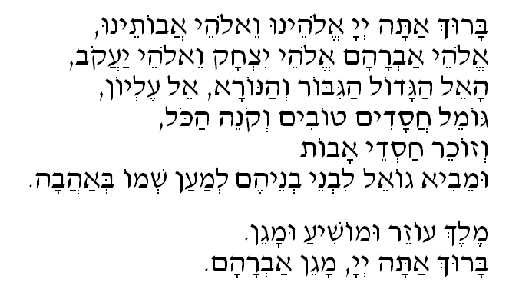
Calendar Check-Off
Each time you recite and sign the blessing segment, write the date in a box, below:
Day 1 | Day 2 |  | Day 3 |  | Day 4 |  | Day 5 |  | Day 6 |  | Day 7
Day 8 |  | Day 9 |  | Day 10 |  | Day 11 |  | Day 12 |  | Day 13

Bonus:

When your calendar is completely filled in, take a PHOTO of you doing one of the signs you learned that especially connects you to God or this blessing. Make sure there’s nothing in the picture that identifies you or your location (no school t-shirts, no names, etc).
- This photo should be emailed to ImGonnaStandUp@jecc.org. We will post it to the Ancestors Silver Challenge page.

